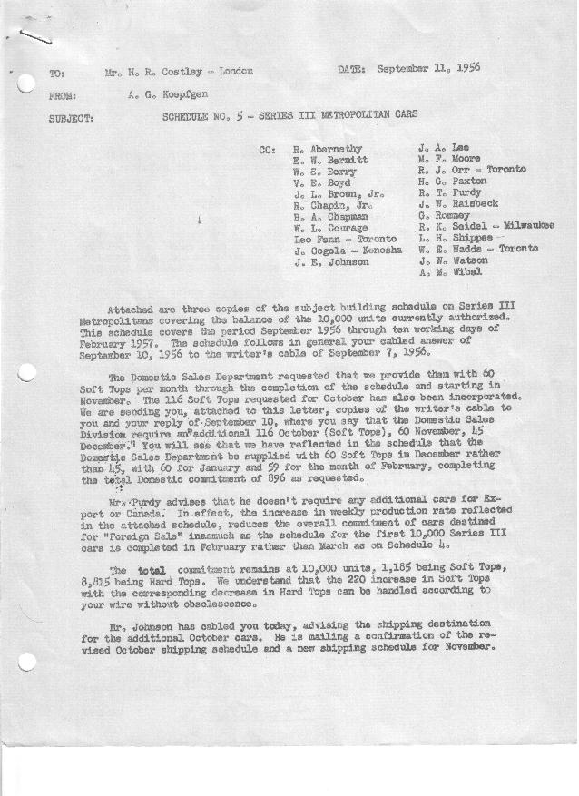

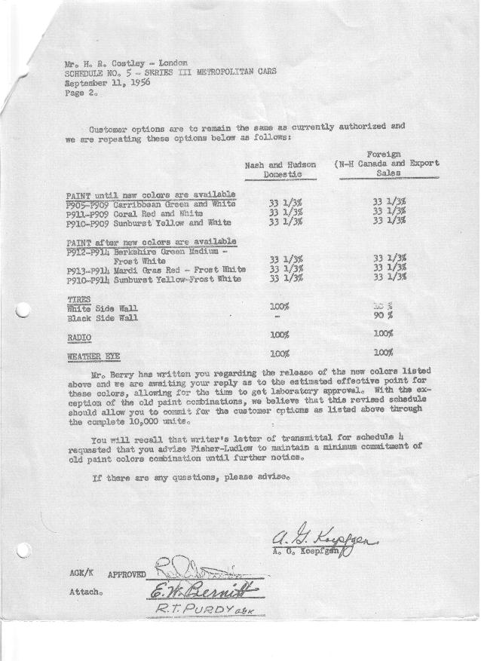

FORM PLAN 68 REV. 2-55-A.M.P Sheet 1 APPROVED R. Abernethy (signed) DATE 9/12/56

SCHEDULE NO. ______5 ___ DATE 9-11-56 MONTHLY BUILDING SCHEDULE APPROVED E.W. Bernitt (signed)_ DATE_ 9/12/56 ____
REVISION NO. _______ _______ DATE PRODUCT APPROVED_R.T. Purdy (signed) ___ __DATE _ 9/13/56 ____
SERIES III 1500 c.c. ENGINE
METROPOLITAN SERIES CARS – AUSTIN MTRS. CO., LTD, ENGLAND
DESCRIPTION | BUILT  ◻ACT EST  THRU  AUGUST | FIRM BUILDING SCHEDULE  (FABRICATED MATERIAL RELEASE) |  |  |  |  |  |  |  |  |  |  |  |  |  |  | TENTATIVE SCHEDULE  (RAW MATERIAL RELEASED) |  |  | GRAND  TOTAL
DESCRIPTION | BUILT  ◻ACT EST  THRU  AUGUST | MONTH SEPTEMBER  DAYS 20 |  |  | MONTH OCTOBER  DAYS 23 |  |  | MONTH NOVEMBER  DAYS 22 |  |  | MONTH DECEMBER  DAYS 18 |  |  | MONTH JANUARY  DAYS 22 |  |  | MONTH FEBRUARY  DAYS 10 |  |  | GRAND  TOTAL
DESCRIPTION | BUILT  ◻ACT EST  THRU  AUGUST | DAILY | MONTH | CUM’L  TOTAL | DAILY | MONTH | CUM’L  TOTAL | DAILY | MONTH | CUM’L  TOTAL | DAILY | MONTH | CUM’L  TOTAL | DAILY | MONTH | CUM’L  TOTAL | DAILY | MONTH | CUM’L TOTAL | GRAND  TOTAL
DOMESTIC:
Hard-Top | 4195 |  | 560 | 4755 |  | 544 | 5299 |  | 702 | 6001 |  | 542 | 6543 |  | 696 | 7239 |  | 164 | 7403
Soft-Top | 541 |  | 0 | 541 |  | 116 | 657 |  | 60 | 717 |  | 60 | 777 |  | 60 | 837 |  | 59 | 896
Total U.S. | 4736 |  | 560 | 5296 |  | 660 | 5956 |  | 762 | 6718 |  | 602 | 7320 |  | 756 | 8076 |  | 223 | 8299
Over/(Under) Sched. No.4 | 41 |  | (41) | -0- |  | 115 | 115 |  | 242 | 357 |  | 180 | 537 |  | 205 | 742 |  | (241) | 501
FOREIGN:
EXPORT Hard-Top | 369 |  | 55 | 424 |  | 93 | 517 |  | 29 | 546 |  | 31 | 577 |  | -0- | 577 |  | -0- | 577
Soft-Top | 210 |  | -0- | 210 |  | -0- | 210 |  | -0- | 210 |  | -0- | 210 |  | -0- | 210 |  | -0- | 210
Total Export | 579 |  | 55 | 634 |  | 93 | 727 |  | 29 | 756 |  | 31 | 787 |  | -0- | 787 |  | -0- | 787
Over/(Under) Sched. No.4 | -0- |  | -0- | -0- |  | -0- | -0- |  | -0- | -0- |  | -0- | -0- |  | -0- | -0- |  | -0- | -0-
CANADA NASH Hard-Top | 185 |  | 125 | 310 |  | 145 | 455 |  | 17 | 472 |  | 28 | 500 |  | 25 | 525 |  | 50 | 575
Soft-Top | 15 |  | -0- | 15 |  | -0- | 15 |  | -0- | 15 |  | -0- | 15 |  | 15 | 30 |  | 26 | 56
Total Nash-Canada | 200 |  | 125 | 325 |  | 145 | 470 |  | 17 | 487 |  | 28 | 515 |  | 40 | 555 |  | 76 | 631
Over/(Under) Sched. No.4 | -0- |  | -0- | -0- |  | -0- | -0- |  | -0- | -0- |  | -0- | -0- |  | -0- | -0- |  | 23 | 23
HUDSON Hard Top | 70 |  | 59 | 129 |  | 68 | 197 |  | 6 | 203 |  | 5 | 208 |  | 15 | 223 |  | 37 | 260
Soft Top | 10 |  | -0- | 10 |  | -0- | 10 |  | -0- | 10 |  | -0- | 10 |  | 3 | 13 |  | 10 | 23
Total Hudson Canada | 80 |  | 59 | 139 |  | 68 | 207 |  | 6 | 213 |  | 5 | 218 |  | 18 | 236 |  | 47 | 283
Over/(Under) Sched. No.4 | -0- |  | -0- | -0- |  | -0- | -0- |  | -0- | -0- |  | -0- | -0- |  | -0- | -0- |  | 7 | 7
TOTAL FOREIGN | 859 |  | 239 | 1098 |  | 306 | 1404 |  | 52 | 1456 |  | 64 | 1520 |  | 58 | 1578 |  | 123 | 1701
Over/(Under) Sched. No.4 | -0- |  | -0- | -0- |  | -0- | -0- |  | -0- | -0- |  | -0- | -0- |  | -0- | -0- |  | 30 | 30
GRAND TOTALS
Hard-Top | 4819 |  | 799 | 5618 |  | 850 | 6468 |  | 754 | 7222 |  | 606 | 7828 |  | 736 | 8564 |  | 251 | 8815
Soft-Top | 776 |  | -0- | 776 |  | 116 | 892 |  | 60 | 952 |  | 60 | 1012 |  | 78 | 1090 |  | 95 | 1185
Total | 5595 |  | 799 | 6394 |  | 966 | 7360 |  | 814 | 8174 |  | 666 | 8840 |  | 814 | 9654 |  | 346 | 10000
Over/(Under) Sched. No.4 | 41 |  | (41) | -0- |  | 115 | 115 |  | 242 | 357 |  | 180 | 537 |  | 205 | 742 |  | (211) | 531

